FOR IMMEDIATE RELEASE
May 10, 2024
Contact: Samantha Talarico
Communications Manager
Email: stalarico@sadd.org

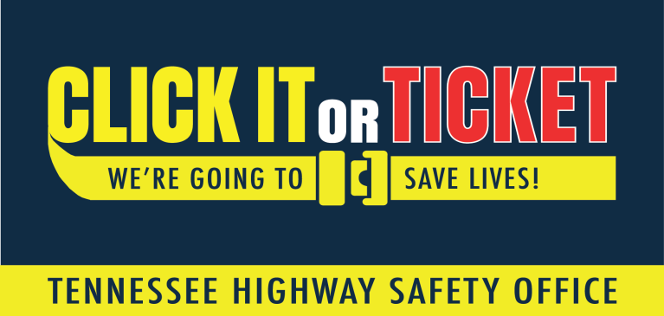

STUDENTS AGAINST DESTRUCTIVE DECISIONS (SADD) EMPOWER TENNESSEE YOUTH TO INCREASE SEAT BELT USAGE AS LAW ENFORCEMENT BUCKLES DOWN FOR “CLICK IT OR TICKET” Mobilization

[Chattanooga, Tennessee] – As summer kicks off and families hit the road for vacation, Students Against Destructive Decisions (SADD) is partnering with the Tennessee Highway Safety Office (THSO) to remind motorists to Click It or Ticket. From May 20 through June 2, participating agencies across the state will increase seat belt enforcement as part of the National Highway Traffic Safety Administration’s (NHTSA) nationwide mobilization.

“We want seat belt use to be an automatic habit for drivers and passengers alike,” said Scott Myers, Executive Director of SADD. “It’s not just a safe thing to do — it’s the law. During the Click It or Ticket campaign, we’ll be working with our fellow law enforcement officers across local and state lines to ensure the message gets out to drivers and passengers. Buckling up is the simplest thing you can do to limit injury or save your life during a crash. We see the results of not wearing a seat belt all the time. We see the loss of life. So often, it could have been prevented.”

Motor vehicle crashes are the leading cause of death for Tennessee teenagers. Each year an average of 68 children aged 15-19 die because of motor vehicle crashes. Motor vehicle crashes are also the leading cause of death for ages 1-14 and the second leading cause for emergency room visits and hospitalizations for this age group.

One focus of the Click It or Ticket campaign is nighttime enforcement. NHTSA data shows a higher number of unrestrained passenger vehicle occupant fatalities happen at night. Also, seat belt use differs among females and males. According to Tennessee’s Integrated Traffic Analysis Network (TITAN), 43% of males killed in Tennessee crashes last year were unrestrained. Of females killed in crashes, 35% were not buckled up. Participating law enforcement agencies will be buckling down on their seatbelt approach in Tennessee.

Since 2015, SADD and State Farm, with THSO, have taken to the community with the Rock the Belt Campaign after NHTSA reported an increase in seatbelt usage among tweens and teens. For more information on implementing this program in your community, visit www.sadd.org/resources.
For more information about seat belt safety, visit www.tntrafficsafety.org/seat-belts.

###
About SADD
For over 40 years, SADD, the nation’s premier youth health & safety organization, has worked to empower teens, engage parents, mobilize communities, and change lives around the issues of traffic safety, substance abuse, and personal health and safety. Through a national network of peer-led chapters in middle schools, high schools, and colleges, SADD equips our students with the resources they need to advocate for change on their campuses and communities. Join the movement by visiting www.sadd.org, and follow us on Facebook, Twitter, YouTube, LinkedIn, and Instagram.

